**SIT 725**

**Applied Software Engineering**

**Task 4.2P**

**Disen Jia**

**223314816**

My GitHub repo link: [SIT725/Task 4.2P/sit725-week4 at main · JudsonJia/SIT725](https://github.com/JudsonJia/SIT725/tree/main/Task%204.2P/sit725-week4)

Screenshots:

MongoDB:

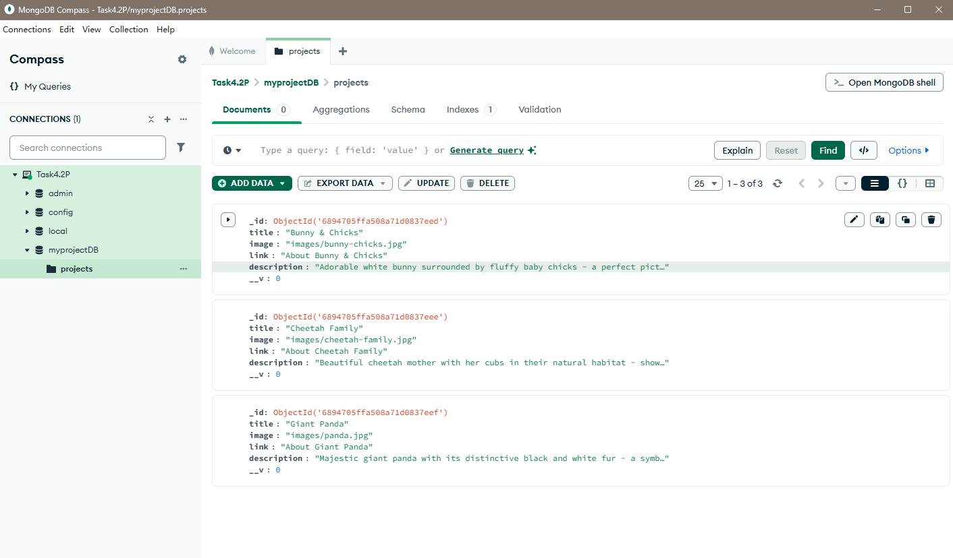

Main Page(stage1):

图形用户界面, 网站

AI 生成的内容可能不正确。

Main Page(stage2), after clicking the button named “click me”:

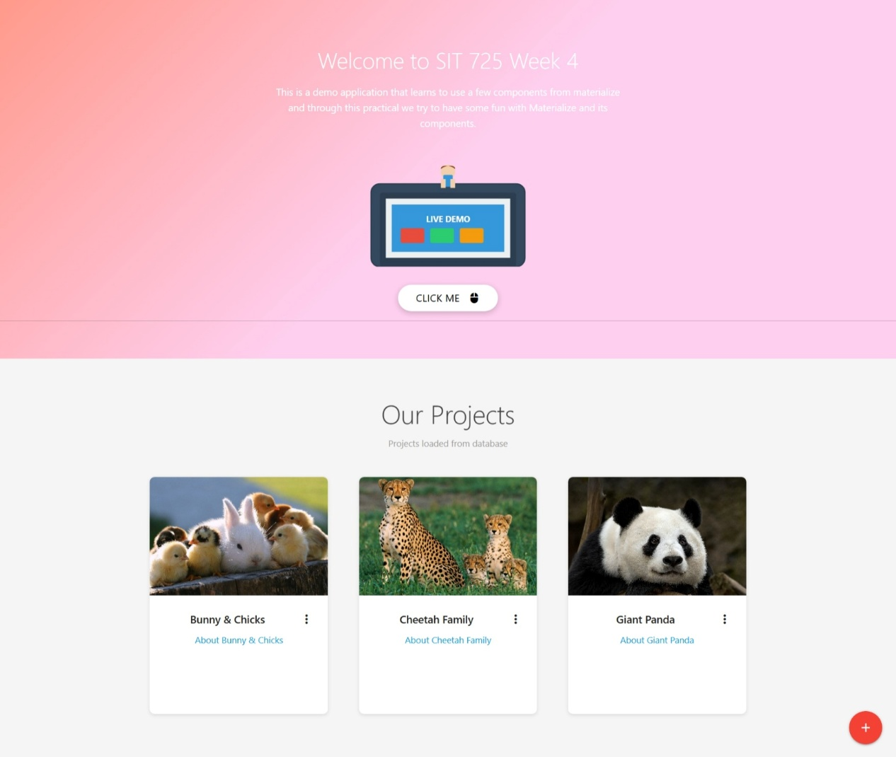

Add a new project functionality:

